***Residency and movement of the deep-water snapper Pristipomoides filamentosus with respect to a network of restricted fishing areas.***

**Abstract**

**Background.** Deepwater bottomfish are a significant cultural and economic resource of the Hawaiian archipelago. In an attempt to curb overfishing of key species, managers established a series of no-take areas throughout the fishery. There is a paucity of information regarding the spatial ecology of these fish in relation to enacted spatial protections. Here we use passive acoustic telemetry to examine long-term spatial use of *Pristipomoides filamentosus,* a key component of the commercial and recreational fishery.

**Methods.** We tagged TK *P. filamentosus* with V13 and V13P acoustic tags (Vemco) between 13 April 2012 and 31 June 2018. Individuals were tracked several acoustic arrays differing in spatial scale to determine the frequency of movement between protected and unprotected waters, describe the home range of individuals, and compare individual home ranges to the scale of spatial protections.

**Results.**

**Discussion.**

**Background**

Fishery Composition

The Hawaiian bottomfish fishery targets a deep-water species complex made up of snappers, jacks, and a grouper species that inhabit island slopes and banks throughout the archipelago at depths ranging between 100 and 400 m (Polovina et al. 1985). Management of the fishery relys on a pooled stock assessment of the seven species representing the complex’s most economically important constituents. These species are known collectively as the deep 7 and include *Pristipomoides filamentosus* (locally referred to as opakapaka) is the species with highest catch abundance, followed by *Etelis courscans* (Onaga), *Etelis carbunculus* (Ehu), and *Pristipomoides sieboldii* (kalekale). *Aphareus rutilans* (lehi), *Pristipomoides zonatus* (gindai), and the endemic Hawaiian grouper *Hyporthodus quernus* (hapuupuu) make up the remainder of the seven managed species (Martell et al. 2006).

## Fishery Management

In Hawaii and the U.S. Pacific Territories, the management of bottomfish resources is a partnership of federal, state, and local agencies (Anonymous 2009). Faced with an overfishing determination in 1998, managers implemented control measures to mitigate overfishing and increase abundance of bottomfish stock components. These efforts included implementing an annual catch limit and network areas across the waters of the main Hawaiian Islands where no bottomfishing activities are permitted. These areas, known as Bottomfish Restricted Fishing Areas, or BRFAs, originally 19 in number, were designed to protect 20% of bottomfish habitat and reduce total mortality by 15% (Anonymous 2006). In 2008, the BRFAs were restructured, reducing the number of protected areas to 12, and incorporating improved knowledge of preferred bottomfish habitat (FIGURE). The goal of this process was to further reduce the total mortality rates to 24% (Anonymous 2006; Moffitt et al. 2006; Weng 2013; Sackett et al. 2014).

## Spatial Restrictions and Controversy

Area restrictions are designed reduce fisher use within the boundaries, alleviating the fishing related mortality on protected individuals. However, if these areas are of insufficient size, they may fail to meet management objectives by permitting the fishery to target vulnerable populations when spillover across boundaries occurs. Furthermore, protection at scales too large may negatively impact those reliant on these resources, either financially or for sustenance (Kramer and Chapman 1999; Botsford et al. 2003; O’Dor et al. 2004; Sale et al. 2005). For this reason, the BRFAs are controversial among stakeholders because they limit access to otherwise fishing grounds. Many of Hawaii’s bottomfish fishers view the BRFA management system as ineffective and unnecessary (Hospital and Beavers 2011). Recently the organization Hawaii Fishermen’s Alliance for Conservation and Tradition has lobbied fishery managers to remove spatial restrictions on the deep 7 fishery.

## The Future of the BRFA Network

NOAA, Hawaii’s Department of Land and Natural Resources, and the Western Pacific Fishery Management Council, who jointly manage bottomfish resources in the Pacific, require information on the movement of bottomfish relative to enacted spatial protection to move forward with management decisions for the fishery (Weng 2013). To make informed decisions, it is imperative that the efficacy of proposed and enacted management measures relative to the movement of these species is assessed. For these reasons, the study of the movements of deep-water Hawaiian fish targeted by the deep 7 commercial fishery in relation to restricted fishing areas has been identified as a top research priority by The Western Pacific Regional Fishery Management Council.

## Present Knowledge of BRFA Effects

There is presently little data to assess how the size of the BRFAs compare to the routine movements of the fish they are supposed to protect (Ziemann and Kelly 2007; Weng 2013). Such knowledge is necessary to understanding and evaluating the efficacy of the areas. Increases in relative size and abundance of bottomfish species, collected by underwater baited stereo cameras, have been shown to increase with time within some BRFAs with effects declining as distance from reserve boundaries is increased (Sackett et al.; Sackett et al. 2014). Conventional mark-release-recapture tagging studies performed by the have provided coarse estimates of the potential scale of bottomfish movement, having recaptured tagged individuals up to 61 km from the site of tagging, however 86% of recovered tags were recovered less than 10 km from the site of tagging (O'Malley 2015). A handful of studies have employed both active and passive acoustic tracking to study the Deep 7 species in Hawaii, however fine scale movement patterns relative to closed area boundaries, and thus the degree of protection provided by these areas to local populations remain poorly understood (Oishi and Devick 2000; Weng 2013; O Malley 2015).

## Acoustic Telemetry to Assess MPAs

There remain fundamental questions regarding the BRFA network that remain unanswered. Of critical importance is how component species use these closed areas. This study used acoustic telemetry to investigate the questions of spatial and temporal use of restricted fishing areas by *Pristipomoides filamentosus,* which account for a significant proportion of the fishery’s catch, (Pooley 1993; Kelley and Moriwake 2012). Each individual fish in the study was surgically implanted with an ultrasonic transmitter with a unique identification number. When a tag transmission is detected by stationary hydrophone receivers moored throughout the study area, the receiver logs the unique identification number, providing a record of the fish’s location in the study area within range of the receiver.

## Study Objectives

The objective of this study was to tag individuals of the species *P. filamentosus* with acoustic tags and track their movements relative to a BRFA to test the following hypotheses:

H1. Bottomfish routinely move across the borders of existing BRFAs.

H2. Bottomfish movements exceed the scale of individual fishery closed areas (BRFAs).

H3. Bottomfish do not utilize habitat uniformly.

## Challenges of Deep Water Acoustic Telemetry Studies

This technology has an established history for evaluating marine reserve protections, but application to the depths frequented by this species is relatively novel and methods for tagging deep-water fish, and designing receiver arrays to track them, remain underdeveloped (Arnold and Dewar 2001; Heupel et al. 2006a; Grothues 2009; Farmer et al. 2013; Pedersen et al. 2014). Application of acoustic telemetry to deep water settings bring along a number of challenges. Barotrauma is a common when landing deep water physoclysts, including *P. filamentosus,* and can result in impairment or mortality of an individual (Vignon & Dierking, 2011; Parrish & Moffit 1992, Demartini et al 1996). The gas bladder of physoclyst fish are closed to the gut. During rapid ascent, barotrauma results from the reduction of external pressure resulting in the expansion of the fish’s gas bladder, and effervescence of gas in blood and other fluids (Brown, et al. 2012). Common symptoms of barotrauma in *P. filamentosus* include tissue embolism, stomach eversion, and exophthalmia (O’Malley 2015). Rapid ascent rates during capture has been linked to higher levels of barotrauma in deep water fish (Parker et al 2006, Hannah & Matterson, 2007, Rogers et al. 2011). Minimizing the time an individual spends on deck, and returning the post-tagged individual to depth using an assisted recompression device are two techniques that have had positive effects on survivorship in species of deep water rockfish (Jarvis and Lowe 2008, Hochhalter & Reed 2011). When designing acoustic tracking arrays, particularly those in water depths in excess of 200 m, close proximity detection interference (CPDI) is another concern (Scherrer et al 2018). CPDI results in the failure of a receiver to log tag transmissions when the transmission’s reflected signal arrives at a receiver with sufficient timing and intensity to interfere with the direct path signal, and are particularly problematic when water depths exceed 200 m (Kessel et al 2015, Scherrer et al 2018).

**Methods**

Movements of *Pristipomoides filamentosus* were observed using passive acoustic telemetry to track individuals relative to BRFAs E and F located off Makapuu and Penguin Banks, respectively. *P. filamentosus* represents the largest fraction of bottomfish catch by the commercial fishery in both pieces and pounds (Kimberly Harding, DLNR [see UR emails]).

*Fish Capture*

All fish in this study were captured with the assistance of commercial fishers using hook and line gear and hydraulic or electric line pullers. Kaka line and make dog rigs are the most common method of bottomfishing in the Hawaiian archipelago and were used to land fish during this study (Anonymous, Hawai’i pelagic handline fisheries: History, trends, and current status; Haight et al 1989). Hooks were baited with squid, anchovies, sardines, and/or saury for bait. When using kaka line rigs, no more than 6 baited hooks were used at a time. Palu, an attractant released when the rig is at fishing depth, consisted of finely chopped bait and an occasionally a filler material such wheat chafe, rice, or oats.

To reduce mortality in this study, when possible, the rate at which the mainline was pulled was slowed to facilitate a more gradual ascent in the hopes of limiting the effects of barotrauma on the individual, while still fast enough as to deter predation. On deck handling of an individual never exceeded 10 minutes in duration and when possible, fish were returned to depth using an assisted recompression device.

*Minimum Size Suitable for Tagging*

It is generally recommended that implanted transmitter tags in teleosts should not exceed 2% of the individual’s body weight (McCleave & Stred 1975, Adams et al. 1998), though other studies have found swimming performance was unaffected with tags weighing up to 6-12% of total body weight (Brown et al. 1999). To determine the minimum size of a *P. filamentosus* eligible for tagging, a V13 and a V13P tag were each weighed to the nearest ten thousandths of a gram on a mass balance. Using the more conservative 2% threshold, we calculated the minimum recommended weight for an individual implanted with each tag type using the following equation:

$$W_{f}= \frac{W_{t}}{0.02}$$

Where $W_{f}$ is the minimum weight of a fish in grams and $W_{t}$ is the weight of a tag. The minimum fork length of *P. filamentosus* eligible for tagging was calculated by solving the following allometric growth function to determine the fork length ( $FL)$ corresponding to each minimum weight ($W_{f})$.

$$FL=a{W_{f}}^{b}$$

Parameter estimates used for the normalization constant, $a$, and the allometric scaling exponent, $b$, were 38.72 and 0.34, respectively (Uchiyama and Kazama, 2003).

*Tagging*

Once aboard the vessel, researchers removed the hook from the fish’s mouth. Fish that were determined to be of acceptable size for tagging were placed in a padded v-board cradle. Oxygenated salt water was passed over the fish’s gills via a saltwater hose or recirculating pump. If severe symptoms of barotrauma, such as buldging eyes or stomach eversion, were visible, the fish’s swim bladder and/or stomach were punctured with a sterile 18-gauge needle. Fish were then positioned so their ventral side faced researchers. An incision, approximately 1.5 – 3 cm in length, was made in along the fish’s ventral centerline in the direction of the anteroposterior axis. A V13 or V13P tag (Vemco, specs TK) was inserted into the peritoneal cavity through the incision. The incision was closed using sutures (Ethicon PDS*Plus antibacterial monofilament) and a reinforced surgeon’s knot secured first with a triple throw, then a double throw, and finally a single throw tied in alternating directions. When available, fish were also tagged externally, between the lateral line and dorsal fin, with a 4 inch PDS-2 dart tag (Hallprint PTY, inc. Hindmarsh Valley, South Australia). These tags were provided by the Pacific Islands Fisheries Group for identification as part of an ongoing mark recapture study. Following surgery, fish were released using a spring-loaded recompression device (Blacktip) to a depth of 20 m (2 atmospheres) or greater.

*Mooring Design*

*Range Testing*

A ranging experiment was performed to determine the detection efficacy of the telemetry system across a range of distances from the receiver. For details of these experiments, see experiment 1/Chapter 2 of Scherrer et al. 2018.

*Receiver Network Array Design*

The receiver network array underwent a number of design changes during the course of this project. The number and placement of receiver moorings was revised to better incorporate early data from tagged fish, the availability of software to optimize receiver placement, and the availability of receiver units including station loss and additional equipment procurement.

Initially, the receiver array used on this project represented a sparse design. Sparse arrays, also known as the ‘fisheries format’ use receivers placed with non-overlapping detection envelopes to monitor the residence and movement of tagged animals when they are within the range of a receiver’s detection envelope (Heupel, Semmens, and Hobday, 2006). A drawback of this design is that it cannot provide continuous monitoring of tagged individuals when they are out of range of array receivers, however arrays of this design are a practical compromise when project budgets make instrumentation and monitoring of the entire study area impractical.

The initial study area spanned waters around Oahu and southwest of Molokai around the Penguin Banks region, where Oahu based fishers are known to frequent. During this phase, the array piggybacked on an array of TK receivers around Oahu for tracking *Hexanchus griseus*, a species of six gilled shark that have been observed frequenting water depths between 245 and 650 m (Comfort and Weng 2015, Comfort and Weng, Unpublished). Nine additional receivers were used to fortify the array with one placed to the north, four to the south, and one within the BRFA off the south-eastern side of Oahu and six placed along the eastern edge of Penguin Banks around and within the BRFA (FIGURE OF RECEIVER ARRAY). This array was used to collect data *P. filamentosus* over a period of 751 days from 13 April 2012 to 4 May 2014.

Analysis of data collected during the initial study phase, and the development of a method for optimizing receiver station placement based on the bathymetry of the study area and species-specific parameters informed a redesign of the receiver network array. This second iteration of the receiver network array shifted receiver resources from Penguin Banks to the Makapuu region with receivers removed from the area on 5 October and 25 October 2014 and the incorporation of 12 additional receivers. Deployment coordinates for receivers within the Makapuu BRFA were determined using The Acoustic Web App (Pedersen, Burgess, & Weng, 2014). Table TK presents the parameters used while running the Acoustic Web App to optimize the receiver array.

The redesigned receiver array network also featured two sub-arrays laid out in a gated configuration. The defining characteristic of a gated array design is the placement of receivers in a linear configuration, such that their detection envelopes overlap, to monitor the movement of tagged individuals into or out of an area with some acceptable threshold limit for detection. The two gated sub-arrays were located to north and south outside of the BRFA’s boundaries to monitor the movement of fish moving into and out of the protected region along the island’s slope. Positioning for nodes in each linear sub-array was performed using the algorithm described in the Positioning of Receiver Gates subsection below.

The array underwent minor changes between 25 June to 30 June 2015 when the receivers comprising the sparse array around Oahu, but not within the Makapuu BRFA were repositioned. At no point in the proceeding period had any tagged *P. filamentosus* been detected on these receivers. Repositioning of these receiver assets allowed the south gate sub-array to be moved from its location near Hanauma Bay, where it was comprised of 4 receiver nodes, to the area 1 km directly South of the BRFA’s southern border. This decision was made to better monitor movement of individuals across the BRFA’s boundary so that there was a reduced opportunity for fish to cross the BRFA’s boundary undetected.

Positions of receiver stations within the Makapuu monitoring array remained constant following the move of the southern gate array. Acquisition of a further 4 receiver units allowed for a modest expansion of the sparse array to fill coverage gaps within the array at the northern end of the BRFA. These receivers were positioned using the same parameters as the initial BRFA sparse array run only over the swath of bathymetry between the northern boundary and northernmost receiver of the existing sparse array. On 7 March 2016, an additional receiver was placed near choice fishing grounds where many individuals had been previously tagged. The positioning of this receiver was determined by researchers rather than through an algorithm. TK receivers were lost at various points in the study, further limiting the data collected from these areas. Receivers lost from gate sub-arrays were replaced when the depths they monitored fell within the habitat designation for *P. filamentosus.* In June 2017, the acquisition of 24 additional receiver assets allowed for further expansion of array coverage. Two additional gate style sub arrays were positioned 1 km inside the boundaries of the BRFA. In conjunction with the existing gate sub-arrays, the addition of these sub-arrays was meant to improve detection of fish moving from inside to outside the protected area and vice versa.

*Positioning of Receiver Gates*

Placement of receiver gates was optimized with respect to the receiver’s probability of detecting a tag transmission over a range of horizontal distances, the bathymetry along the target transect, upper and lower depths the gate needed to encompass, the height of the receiver off the seafloor, desired height of the water column to monitor, the swimming speed of the species, and the minimum acceptable detection rate of the gate. Each receiver was then placed according to an algorithm that functioned as follows: The minimum distance between any two receivers is determined with the following set of equations.

$Y_{dt}=Y_{f}- Y_{r}$

$x_{dt}≤{ 2\left({{{r_{dt}}^{2}-y}_{dt}}^{2}\right)}^{\frac{1}{2}}$

$D_{r}≤ {2x}_{dt}$

The effective fence height ( $Y_{dt})$ is the minimum height of the fence off the seafloor ( $Y_{f})$ minus the height of the receiver from the seafloor ($Y_{r})$. The receiver’s hydrophone is assumed to be omnidirectional with a detection envelope approximating a sphere, that is, a receiver has an equal probability of detecting a tag for any two coordinate sets that produce equivalent primary transmission path lengths. From this, the algorithm can calculate half the distance between any two subsequent receivers in the fence ( $x_{dt})$ using the effective fence height ($Y_{dt})$, the radial distance at which the receiver’s detection function falls below ½ the minimum acceptable detection rate of the gate ${(r}_{dt})$ using Pythagorean’s theorem and multiplying the result by two, as the spacing between each receiver is two equal hemispheres. The algorithm uses the radius at half the desired detection threshold for inter-receiver spacing because the probability of detection at either receiver is independent of detection at the other, and thus, using the additive property for probability, the total probability of either receiver detecting the transmission is equal to the minimum acceptable detection rate. Receivers are placed so that their line-of-sight distance does not exceed this maximum allowable distance.

The algorithm then calculates the distance between two subsequent nodes of the fence for the minimum acceptable detection rate of the gate was two times that of the desired rate using the same method. This step is important as the detection envelope of receivers at either end of the fence will not overlap, and as such, the probability of detecting a single transmission at either end of the gate is dependent only on the single receiver. Calculating the distance between two receivers with two times the desired detection rate of the gate produces an inter-receiver spacing that is equal to the distance the detection envelope of each of these receivers will monitor.

The algorithm then calculates the distance across the seafloor along the line of the transect by calculating the distance between each bathymetric data point, again using Pythagorean’s theorem. This allows the algorithm to take into account the effect of sloping bottoms where the line-of-sight distance between two receivers is greater than their horizontal distance. The algorithm then positions the two receivers at half the distance determined for receivers with two times the desired detection rate of the gate from either end of the transect. The seafloor distance along the transect between these two receivers is divided by the distance between subsequent nodes calculated using half of the minimum acceptable detection rate and rounded to the next whole integer. This integer is one greater than the receivers required to create the fence, not accounting for the two end receivers whose placements have already been determined. The distance between the end receivers is divided by the required receivers, producing a new inter-receiver spacing that is equal to or less than the maximum spacing determined by equation 2. Receivers are placed at line-of-sight intervals equal to this new spacing between the two ends of the gate. The algorithm then checks to ensure that at no point does the bathymetry along the gate transect interfere with the line-of-sight between any two subsequent receivers.

The algorithm then calculates the minimum interval between subsequent tag transmissions to ensure a tag will transmit while a fish traverses the gate. The plane of intersection at which two spheres intersect forms a circle. A horizontal chord is drawn along the minimum desired fence height. The distance of this chord represents the path through the fence with the lowest likelihood of detection. Multiplying the length of this chord by the swimming speed of the tagged animal gives the minimum time an animal can traverse the gate. The quotient of the minimum time required to traverse the gate, and the tag’s transmission interval gives an estimate of the number of transmissions from a tagged individual along this path. Provided the transmission interval is less the minimum time required to traverse the gate, the individual has a probability of detection greater than or equal to the minimum acceptable detection rate of the gate. The probability of any one transmission from a tag being detected is independent of the one that proceeded it, the probability of detecting an individual at least once as it swims through the gate is equal to the sum of the detection probability of that animal at the point of each transmission. This means that the true detection probability for a tag that transmits multiple times while passing through a gate is significantly higher than the minimum acceptable detection rate of the gate itself. Using this method, we calculated deployment coordinates and depths for each receiver component of the gate and ensure that the probability of detection for an individual along any path is greater than zero.

*Close proximity detection interference*

*Data Analysis - Phase Separation*

Work tracking *P. filamentosus* has occurred in two major phases. Analysis of data collected during the course of this project has been split to reflect the substantial differences in study design between these two periods. During the first phase (Phase I), 52 *P. filamentosus* were captured and tagged two primary locations, the slopes of the Makapuu shelf, located off the eastern end of the island of Oahu, and the eastern slope of the Penguin Banks region extending south west of the island of Molokai. The receiver array on which individuals were tracked during this period was designed to instrument select areas around Oahu and Penguin Banks and included parts of BRFAs D,E, and F (FIGURE). Phase I began on 13 April 2012 with the final transmission detected on 18 January 2015. In total, Phase I lasted for a period of 766 days.

Early analysis of Phase I data showed very few detections of tagged fish at multiple receivers and some fish with records of prolonged residency at a preferred receiver. Such patterns could indicate the spacing between receiver array units was exceeded the majority of movements by tagged individuals, and/or the positioning of some receivers in locations of sub-optimal habitat. Attempting to ameliorate these issues, the scope of the project was narrowed to focus on the Makapuu region and BRFA E. Presently Phase II targets *P. filamentosus* only in the Makpauu shelf region. To date, 54 *P. filamentosus* have been released with acoustic tags as a part of Phase II.

*Data Analysis - Mortality Scenarios*

Create mortality flowchart (see fish mortality.xmind)

High tagging mortality and what appear to be moderate to high residency rates of observed in tagged *P. filamentosus* make determining tag status difficult, that is, it is difficult to be certain whether a tagged fish has died, or simply does not move very far. Tracks of tagged fish have therefore been assigned to one of three categories. Viable tracks are those detection records believed to come from free living individuals. A transmitter detected at multiple receivers, tracked for period of greater than 10 days, with no sudden changes in behavior occurring in the last 5 days is believed to represent a viable free-swimming individual. Expired tracks are the result of a mortality event. Individual tag records observed traveling rapidly over extended distances followed by a cessation of detections or prolonged detections at a single receiver with little variability in the number of daily detections for the remainder of the transmitter’s estimated battery life is likely to be caused by a predation event. The status of some tracks does not fit easily into a viable or expired narrative, for instance, a tag observed with extended detection periods at a single receiver may be interpreted as a display of prolonged spatial residency by a surviving fish, or a case where the tag of a deceased individual came to rest in proximity to a receiver. In these cases, the tracks are classified as questionable. The category of questionable status tracks likely includes both valid and expired tracks.

We present two analysis scenarios, one representing only fish of viable status, and a second with the inclusion of questionable tracks. The viable only results represent the most conservative estimates of overall mortality, however by necessity come from a smaller sample over fish. Inclusion of questionable tracks in analysis may support behavior patterns found in viable fish or reveal new patterns of behavior, but risk inclusion of tracks from expired fish. When results from viable and questionable groups differ, these differences will be discussed.

*Network Design*

During both Phases, mooring design used to construct individual nodes of the tracking array were identical. Each station consisted of an acoustic receiver unit (Vemco VR2W), vertically oriented to the seafloor suspended between 2 and 4 meters below three 10 inch diameter trawl floats on a purchase of line attached to an acoustic release (Sonardyne LRT). The acoustic release was attached to a 108 kg concrete mass anchor to create a semi-permanent mooring unit. Over the course of the study, the acoustic releases were periodically triggered to facilitate the recovery and offload of receiver data. Acoustic receivers and releases were cleaned and refurbished with new batteries, attached to a new set of block anchors, and redeployed in study locations.

The acoustic receiver tracking array used to collect transmissions from tagged individuals underwent substantive changes between Phase I and Phase II. A summary of each network’s layout is described below.

*Testing Hypotheses:*

Hypothesis 1 was tested by determining if location coordinates for each tag detection occurred within our outside BRFA boundaries. Movement across BRFA boundaries was said to occur when a tag was detected outside of BRFA boundaries followed by a detection within BRFA boundaries, or vice versa. The number of movements across BRFA boundaries was then standardized by the time at liberty, the number of days elapsed between tagging and the final detection of a tag.

Hypothesis 2 was tested by calculating the home range size for tags that were detected at 3 or more locations, including the location the individual was tagged. Home range size was determined by fitting a polygon to the most northern, southern, eastern, and western coordinates an individual was detected. The average length of this polygon, estimated by the square root of the home range size was compared the average length dimensions of the BRFAs. For tags that were detected at only two locations, the linear geodesic distance was calculated between the two known locations and compared to the average BRFA length dimension.

Hypothesis 3 was tested by comparing detection of tags moving between two stations. A two dimensional matrix was constructed with the number of rows and columns equal to the number of total stations tags were detected. Each station was assigned a unique row and column. Each detection for each fish was compared to the one previous. The for each detection pair, the matrix values were incremented by one with rows representing the location of the previous detection and columns representing the present location. The diagonal values of the matrix identify subsequent detections at the same station. A fish may be more likely to be detected at adjacent stations than stations with further physical separation. Attempting to account for this, row and column value was multiplied by the calculated distance between their representative locations and then divided by the maximum value to standardize flow rates relative to a maximum value of 1.

**Results**

*Fish Capture and Tagging*

During the first phase of this project,

*Minimum Size Suitable for Tagging*

The V13 tag weighted 10.2024 g. The corresponding minimum fish weight, using the 2% guideline was 0.51012 kg. Using the allometric weight/length relationship, we calculated the minimum fork length to be 30.70 cm. The V13P tag, weighing 12.7698 g corresponded to a minimum fish weight of 0.63849 kg and a fork length of 33.17 cm.

*Telemetry Hardware*

*Network Design - Phase I*

During Phase I, receiver moorings were deployed around Oahu and Penguin Banks. Exact location of each receiver was made using researcher intuition in locations consistent with a water depth ranging between 100-400 m, the essential fish habitat (EFH) for the bottomfish species complex. In total, 19 receiver moorings were placed with respects to BFRA boundaries with the intention of monitoring the coming and going of tagged fish across these boundaries and across larger scales which constituted the phase 1 acoustic array (Figure).

During the course of the study, four receiver stations were lost. Failure to recover these stations is presumed to be due to equipment failure or entanglement with equipment from vessels operating in the vicinity. As a result of these losses, receiver data is unavailable for the Penguin Banks - Third Finger station after day 337, Oahu - Kahuku station after study date 541, and Penguin Banks - The Mound Station between study dates 330 and 593. The Penguin Banks - Drop Off (In BRFA) station suffered receiver loss on two separate occasions and thus no data is available for this station, reducing our ability to observe movements into and out of the Penguin Banks BRFA. In this configuration, the mean geodesic distance between any two receivers was 50.95 km ± 27.97 km.

*Network Design - Phase II*

Following recovery and analysis of data from the acoustic network during Phase I, it was evident that the scale of the tracking network was far exceeded that of observed movement patterns for tagged opakapaka. Extensive range testing experiments were performed to understand the distance from an receiver that a single transmission from a tagged fish could reasonably be detected.

Work was also undertaken to construct software for optimize the positioning of acoustic receivers within a network to deploy resources with respect to preferred fish habitat, and to aid in the design of linear deployments of receivers with overlapping detection fields (acoustic fences) to capture the movements of tagged fish swimming through the fence. In 2014, the tracking network was redesigned to incorporate improved knowledge of opakapaka movement behaviors from Phase I using these tools (FIGURE).

*Testing Hypotheses*

*Hypothesis 1: Bottomfish routinely move across the borders of existing BRFAs.*

*Conservative Scenario – Valid tracks only*

Four of the 12 valid tracks were detected making seven movements across the BRFA Boundaries. One fish tagged south of the BRFA was detected at stations inside the BRFA and then observed again outside the BRFA indicating movement across the boundary. A second fish exhibited opposite behavior, having been tagged inside the BRFA, detected at a station outside the BRFA and then again at stations inside. A third tag was detected moving from a tagging location south of the BRFA before taking up residence inside the BRFA. And finally, a tag tagged in the BRFA was detected moving south of the BRFA, then back into the BRFA, before moving back out of the BRFA again. Standardized by time at liberty, a given fish was observed crossing into or out of the BRFA approximately once every 181 days (mean crossings per day = 0.00554, standard deviation = 0.00864). The median number of crossings under this scenario was zero (Min = 0, 1st Quantile = 0, 3rd Quantile = 0.0120, Max = 0.0213)

*Less Conservative Scenario – Valid and Questionable tracks*

Inclusion of additional tags from fish with undetermined fates increases the number of observed movements across BRFA boundaries to 31. For these tracks, 12 of the 25 were detected crossing the southern BRFA boundary at least once with one fish detected crossing from within the BRFA over the northern boundary of the BRFA. One of these tags was detected moving across the southern BRFA boundary 12 times, six movements from outside to inside, and six movements from inside to out. Another tag was detected crossing the boundary eight times, four times in each direction. A third tag was detected crossing six times, with three movements in and three movements out. Eight tags were detected moving over the boundary twice, once in either direction. Finally, two tags were detected moving from inside the BRFA to outside. Standardized by time at liberty, a given fish was observed crossing into or out of the BRFA approximately once every 8 days (mean crossings per day = 0.134, standard deviation = 0.216). The median number of crossings standardized by time at liberty under this scenario was 0.585 (Min = 0, 1st Quantile = 0, 3rd Quantile = 0.254, Max = 0.655).

*Hypothesis 2: Bottomfish movements exceed the scale of individual fishery closed areas(BRFAs).*

Hypothesis 2 was tested by calculating the home range size for tags that were detected at 3 or more locations, including the location the individual was tagged. Home range size was determined by fitting a polygon to the most northern, southern, eastern, and western coordinates an individual was detected. The average length of this polygon, estimated by the square root of the home range size was compared the average length dimensions of the BRFAs Median value 9.04 km (Min = 6.11, 1st Quantile = 8.75, 3rd Quantile = 14.98, Max = 16.39). For tags that were detected at only two locations, a linear geodesic distance was calculated between the two points and compared to the average BRFA length dimension.

*Conservative Scenario – Valid tracks only*

Of the 12 tags, eight had three or more positions allowing the max polygon area approach to be used. The mean area for these seven tags was 3.12 km2 (standard deviation = 3.12) with a median value of 2.27 km2 (Min = 0.107, 1st Quantile = 403, 3rd Quantile = 5.57, Max = 8.38) resulting in a mean square rooted area of 1.51 km (standard deviation = 0.990) and a median square rooted area of 1.50 km (Min = 0.327, 1st Quantile = 0.629, 3rd Quantile = 2.28, Max = 2.89). The mean maximum linear distance determined for all 12 tags was 3.74 km (standard deviation = 4.03) with a median distance of 2.40 km (Min = 0.606, 1st Quantile = 0.866, 3rd Quantile = 5.14, Max = 14.6).

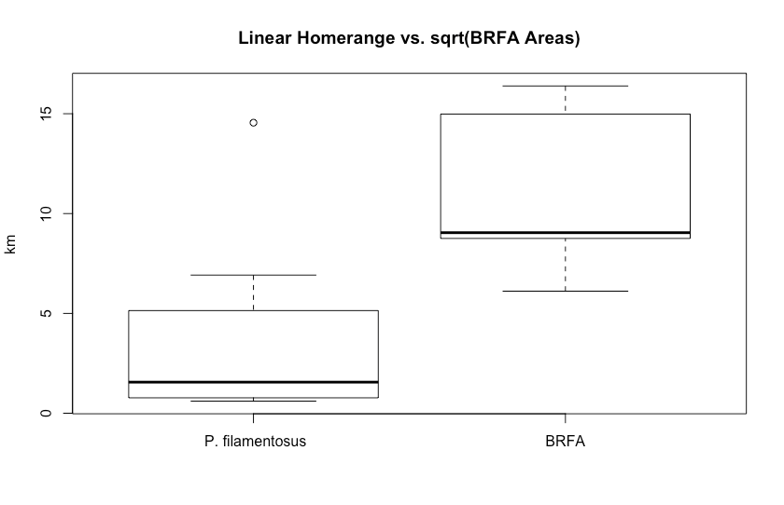

*Less Conservative Scenario – Valid and Questionable tracks*

Of the 25 tags possessing both valid and questionable tracks, 17 tags were detected at 3 or more locations allowing for max polygon area estimation. The mean area of these 17 tags was 4.42 km2 (standard deviation = 4.81) with a median value of 2.89 km2 (Min = 0.00011, 1st Quantile = 1.76, 3rd Quantile = 6.26, Max = 19.6). This resulted in a mean square rooted linear size of 1.81 km (standard deviation = 1.10) and a median square rooted linear size of 2.25 km (Min = 0.0105, 1st Quantile = 1.33, 3rd Quantile = 2.50, Max = 4.43). The mean maximum linear distance determined for all 25 tags was 4.00 km (standard deviation = 4.45). The median linear distance for all 25 tags was 3.90 km (Min = 0.605, 1st Quantile 1.805, 3rd Quantile = 6.09, Max = 14.93).

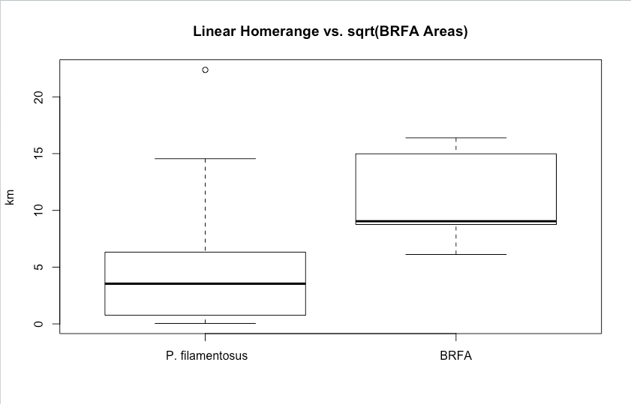

*Hypothesis 3: P. filamentosus do not utilize habitat uniformly.*

*Conservative Scenario – Valid tracks only*

Overwhelmingly tags were detected primarily at a single station with location varying by tag. Movements between stations occurred most frequently between neighboring stations, particularly those of close proximity along the southern fence. Movements into and out of the BRFA occurred from stations 14 and 15, located within the southern end of the BRFA in approximately 84 m and 110 water depth respectively, to stations 26 and 27 located in 165 m and 97 m as well as a receiver that was present for only the first 6 months of the study located at 115 m water to the east of Hanauma Bay. Movements were also observed across stations 25 (at a depth of 216 m), 26, and 27 with the most frequent movements observed occurring between stations 26 to 27. As well, movements from station 12 within the the BRFA (at a depth of 69 m) were observed occurring to stations 14 and 15 but no movements were directly observed between this station and stations outside the BRFA. Movements out of the BRFA all had station 15 as their end destination. While all stations are within the essential fish habitat definition for bottomfish, it appears that the tagged *P. filamentosus* had a preference for travel between the areas monitored by the specific stations described.

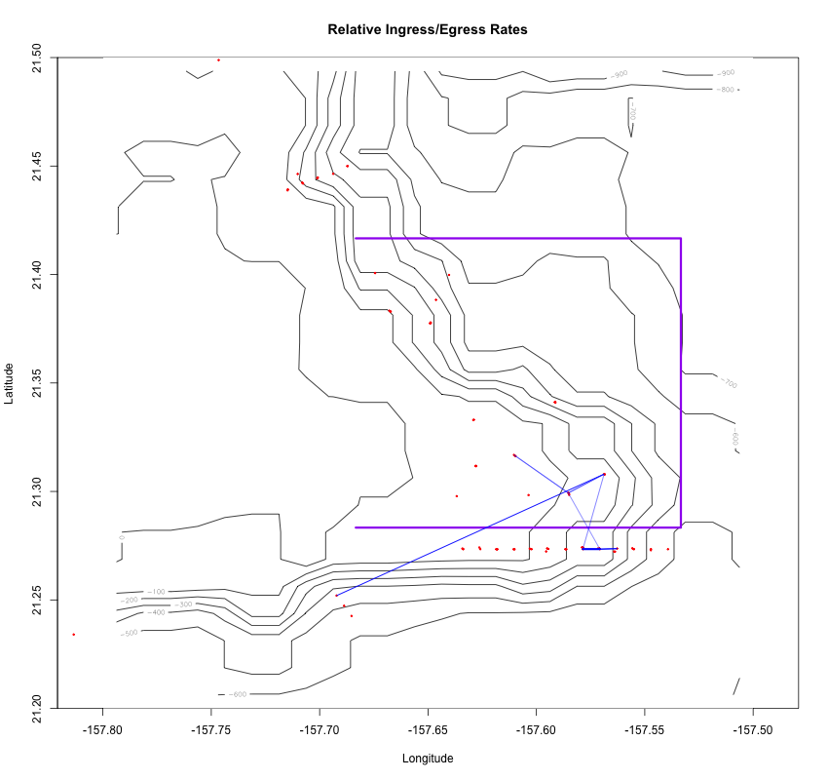

Figure showing tracks between different receivers. Receiver locations are indicated with a red dot and the thickness of the blue track lines indicate standardized path usage for ingress/egress between station pairs. BRFA boundaries are outlined in purple.

*Less Conservative Scenario – Valid and Questionable tracks*

There were more movements across a greater number of stations when questionable tracks were included. The highest rates of movement were again observed between adjacent receivers, even when standardized. Station 14 had the highest rates of standardized egress with fish observed leaving the BRFA with movements into station 26, 27, 28, 29 and 30. Station 28 (89 m depth) had the highest standardized egress rates of any of the outside stations into the BRFA with tags observed moving between stations 11 (50 m depth), 13 (73 m), and 14. Stations 14 and 28 also had the highest ingress rates with station 14 being a destination for tags moving from outside BRFA stations 26, 27, 28, 29 and 30 and station 28 the destination for tags from inside BRFA stations 13 and 14. In this scenario overall, tagged fish undertook a greater number of movements across a greater combination of stations.

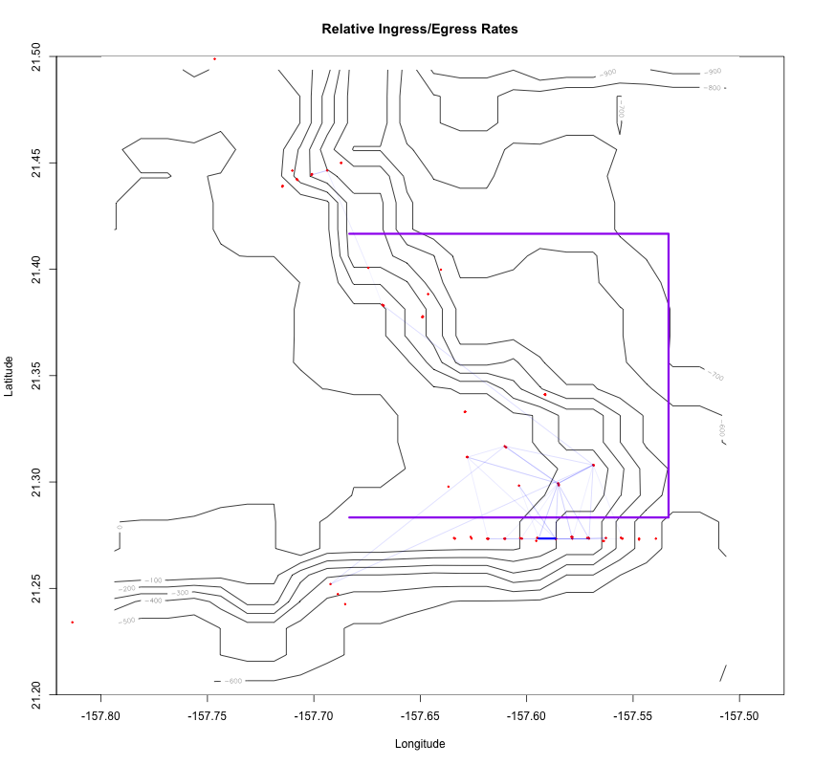

Figure showing tracks between different receivers. Receiver locations are indicated with a red dot and the thickness of the blue track lines indicate standardized path usage for ingress/egress between station pairs. BRFA boundaries are outlined in purple.

# **Discussion**

# **Conclusion**

# **References**